

+6013-7943364

basyirghazali92 @gmail.com

No 18 Jalan Perak 4,

Taman Sri Skudai, 81300, Skudai, Johor, Malaysia.

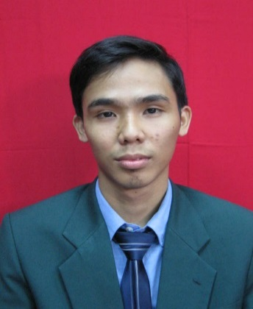

MUHAMMAD BASYIR

MOHAMAD GHAZALI

 **CAREER OBJECTIVE**

|  |  |  |
| --- | --- | --- |
| 1. Office Software | Microsoft Word 2013  Microsoft Powerpoint 2013  Microsoft Excel 2013 | Excellent Excellent Intermediate |
| 2. Other Software | Revit Autodesk 2014 | Beginner |

 **CORE SKILLS**

 **EDUCATION & ACHIEVEMENTS**

* Looking for a challenging career in an organization where I could learn under working professional to gain knowledge and improvement of my skills by giving some input to the company.

|  |  |  |
| --- | --- | --- |
| Language | Written | Spoken |
| English | Good | Good |
| Malay | Excellent | Excellent |

Bachelor of Quantity Surveying | 2013-2016 Universiti Teknologi Malaysia, (UTM)

CGPA: 2.94

Diploma in Quantity Surveying | 2010-2013 Universiti Teknologi Malaysia, (UTM)

CGPA: 3.02

**PRE PROFESSIONAL EXPERIENCE**



Assistant Quantity Surveyor | Nov 2016 - Present

DEKAD JITU SDN. BHD.

Scope of work:

* **Key in data from site & sketch drawing**
* **Taking off and measurement of quantities**
* **Purchasing Order**
* **Fill The Tender Price**

Practical Trainee | May 2012 - September 2012, Feb 2015 – July 2015

MRQS CONSULTANT

Scope of work:

* **Key in data from site & sketch drawing.**
* **Taking off and measurement of quantities.**
* **Bills of Quantity preparation.**
* **Tender document preparation.**
* **Evaluation of work done on site.**
* **Site meetings participation.**
* **Contractual procurement**

**PARTICIPATION**

* + Building Information Modelling Technical Training (5D BIM), University Technology Malaysia
  + Autodesk Revit 2014 Fundamental Training, University Technology Malaysia
  + Inaugural Futsal Competition 2013 RISM-Johor Branch

**REFERENCE**

DR. SARAJUL FIKRI BIN MOHAMED

Academic Advisor

Department of Quantity Surveying Faculty of Built Environment

University Technology Malaysia

81310, UTM Johor Baharu Johor, Malaysia

+6019-7595806